**TAMPERE UNIVERSITY**

**DEE-24106 Electric Power System**

**SHORT-CIRCUIT FAULT CURRENT CALCULATIONS**

**Assignment - 1 Report**

|  |  |
| --- | --- |
| **Name** | **ID** |
| Md Nurunnabi Emon | 281732 |
| Sayad Mohammad Mahadi Hassan | 281750 |

Date: 01-Fab-2019

**Three-phase power transmission line configuration and circuit represented by one-line diagram -**

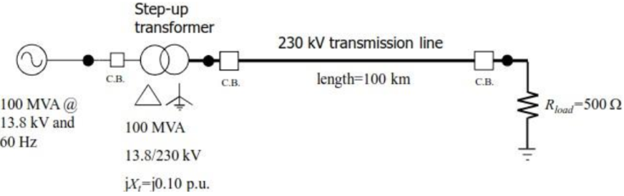

From the above Figures, we can obtain below information:

Transmission line voltage = 230 Kv

Ground with conductivity s = 0.01S/m

Transmission line, L = 100 km

Operating in, f = 60 Hz

# This assignment problem calculation is done by a MATLab program.

1. **Calculation of the Sequence Impedances**

The calculated Z_series Impedance Matrix [ohm/km] from PSCAD of fully transposed system:

*Z_SERIES = $\left[\begin{matrix}12.92+65.32i & 11.65+29.11i & 11.04+24.25i \\ 11.65+29.11i & 13.99+64.62i & 11.65+29.11i \\ 11.04+24.25i & 11.65+29.11i & 12.92+65.32i\end{matrix}\right]$ Ω*

To obtain transmission line’s positive, negative and zero sequence, we apply following formula:

$$Z_{0}=Z+2M$$

$${ Z}_{1}=Z_{2}=Z-M$$

$Z_{1}=Z_{2}= \left[\begin{matrix}1.83+37.60i & 0+0i & 0+0i \\ 0+0i & 1.83+37.60i & 0+0i \\ 0+0i & 0+0i & 1.83+37.60i\end{matrix}\right]$*Ω*

$Z_{0}= \left[\begin{matrix}36.17+120.07i & 0+0i & 0+0i \\ 0+0i & 36.17+120.07i & 0+0i \\ 0+0i & 0+0i & 36.17+120.07i\end{matrix}\right]$*Ω*

$Z_{SEQ}= \left[\begin{matrix}36.17+120.07i & 0+0i & 0+0i \\ 0+0i & 1.83+37.60i & 0+0i \\ 0+0i & 0+0i & 1.83+37.60i\end{matrix}\right]$*Ω*

To express the transmission line sequence parameters and the resistive load in the power transmission circuit on a per-unit basis, we have selected 230 kV as the base voltage and 100 MVA as the base power.

So, $Z_{b}=\frac{{V_{b}}^{2}}{S_{b}}=\frac{{(230×{10}^{3})}^{2}}{100×{10}^{6}}=529Ω$

Since, $Z_{pu}={Z_{actual}}/{Z_{b}}$

$Z_{1}=Z_{2}= \left[\begin{matrix}0.0035+0.0711i & 0+0i & 0+0i \\ 0+0i & 0.0035+0.0711i & 0+0i \\ 0+0i & 0+0i & 0.0035+0.0711i\end{matrix}\right]$*p.u*

$Z_{0}= \left[\begin{matrix}0.0684+0.2270i & 0+0i & 0+0i \\ 0+0i & 0.0684+0.2270i & 0+0i \\ 0+0i & 0+0i & 0.0684+0.2270i\end{matrix}\right]$*p.u*

$Z_{SEQ}= \left[\begin{matrix}0.0684+0.2270i & 0+0i & 0+0i \\ 0+0i & 0.0035+0.0711i & 0+0i \\ 0+0i & 0+0i & 0.0035+0.0711i\end{matrix}\right]$*p.u*

1. **Main Stages of Power Flow Solution**

From the impedance, we can obtain admittance:

$${ Y}_{1}={ Y}_{2}= \left[\begin{matrix}0.6833-14.0371i & 0+0i & 0+0i \\ 0+0i & 0.6833-14.0371i & 0+0i \\ 0+0i & 0+0i & 0.6833-14.0371i\end{matrix}\right]$$

$$Y_{0}= \left[\begin{matrix}1.2168-4.0393i & 0+0i & 0+0i \\ 0+0i & 1.2168-4.0393i & 0+0i \\ 0+0i & 0+0i & 1.2168-4.0393i\end{matrix}\right]$$

$$Y_{SEQ}= \left[\begin{matrix}0.0023-0.0076i & 0+0i & 0+0i \\ 0+0i & 0.0013-0.0265i & 0+0i \\ 0+0i & 0+0i & 0.0013-0.0265i\end{matrix}\right]$$

So, the nodal admittance matrix is:

*Y = G + jB = $\left[\begin{matrix}0.6833-24.0371i & -0.6833+14.0371i \\ -0.6833+14.0371i & 0.6833-24.0371i\end{matrix}\right]$*

1. **Short-Circuit Fault Current Calculations**

$I_{base}= \frac{100x10^{6}}{\sqrt{3}*230{x10}^{3}}=251$ A

1. Three-phase-to-ground:

In this case considering positive sequence, we apply this formula:

$$I_{1.f}=\frac{E}{Z_{1}+Z_{f}}$$

Here, E = 1 pu

${ Z}_{f}$ = 0.01/ $Z_{b}$; in ohm per 100km

Z1 = Zg + Z_tl_1 + Z_t; (from MATLab program)

Zg = 0; +ve seq values of gen, transmission line, transformer and fault impedance.

Z_tl_1 = Z_pu (2,2); Z_series in pu.

Z_t = 0.1i;

So the positive sequence fault current is:

$$I_{f_3ph_1}=0.1188 - 5.8431i$$

Then we can obtain the fault current sequence in phase $I_{f_3ph_seq}=\left[\begin{matrix}0+0i \\ 0.1188 - 5.8431i \\ 0+0i\end{matrix}\right]$

By multiply with**Ts = $\left[\begin{matrix}1 & 1 & 1 \\ 1 & a2 & a \\ 1 & a & a2\end{matrix}\right]$** and $I_{base}$

We can get the KA value:

$$I_{f_3ph}=\left[\begin{matrix}0.0298- 1.4666i \\ -1.2850 + 0.7075i \\ 1.2552 + 0.7591i\end{matrix}\right]$$

1. Single-phase-to-ground fault

We apply this formula:

$$\left[\begin{matrix}I_{0.f} \\ I_{1.f} \\ I_{2.f}\end{matrix}\right]=\frac{1}{Z_{0}+Z_{1}+Z_{2}+{3Z}_{f}}\left[\begin{matrix}E \\ E \\ E\end{matrix}\right]$$

Then we can obtain the fault current sequence in phase:

$$I_{f_1ph_seq}=\left[\begin{matrix}0.1662 - 1.4758i \\ 0.1662 - 1.4758i \\ 0.1662 - 1.4758i\end{matrix}\right]$$

By multiply with **Ts = $\left[\begin{matrix}1 & 1 & 1 \\ 1 & a2 & a \\ 1 & a & a2\end{matrix}\right]$**  and $I_{base}$

We can get the KA value:

$$I_{f_1ph}=\left[\begin{matrix}0.1251 - 1.1113i \\ 0+0i \\ 0+0i\end{matrix}\right]$$

1. 2-phase Fault

We apply this formula:

$$\left[\begin{matrix}I_{0.f} \\ I_{1.f} \\ I_{2.f}\end{matrix}\right]=\frac{1}{3（Z_{1}+Z_{2}+Z_{f}）}\left[\begin{matrix}0 \\ -j√3E \\ j√3E\end{matrix}\right]=\frac{1}{Z_{1}+Z_{2}+Z_{f}}\left[\begin{matrix}0 \\ E \\ -E\end{matrix}\right]$$

Then we can obtain the fault current sequence in phase:

$$I_{f_2ph_seq}=\left[\begin{matrix}0+0i \\ 0.0592- 2.9216i \\ -0.0592+2.9216i\end{matrix}\right]$$

By multiply with **Ts = $\left[\begin{matrix}1 & 1 & 1 \\ 1 & a2 & a \\ 1 & a & a2\end{matrix}\right]$**  and $I_{base}$

We can get the KA value:

$$I_{f_2ph}=\left[\begin{matrix}0+0i \\ -1.2701 - 0.0258i \\ 1.2701+ 0.0258i\end{matrix}\right]$$

1. 2-phase-to-ground Fault

We apply this formula: $\left[\begin{matrix}I_{0.f} \\ I_{1.f} \\ I_{2.f}\end{matrix}\right]=\frac{1}{(Z_{1}+Z_{f})({Z_{2}+Z}_{f})+(Z_{1}+Z_{f})(Z_{0}+Z_{f})+(Z_{2}+Z_{f})(Z_{0}+Z_{f})}\left[\begin{matrix}-({Z_{2}+Z}_{f})E \\ ((Z_{2}+Z_{f})+(Z_{0}+Z_{f}))E \\ -(Z_{0}+Z_{f})E\end{matrix}\right]$

Then we can obtain the fault current sequence in phase:

$$I_{f_2phg_seq}=\left[\begin{matrix}-0.2003 + 1.1781i \\ 0.1595 - 3.5106i \\ 0.0407 + 2.3325i\end{matrix}\right]$$

By multiply with **Ts = $\left[\begin{matrix}1 & 1 & 1 \\ 1 & a2 & a \\ 1 & a & a2\end{matrix}\right]$**  and $I_{base}$

We can get the KA value:

$$I_{f_2phg}=\left[\begin{matrix}0.0000 + 0.0000i \\ -1.3455 + 0.4177i \\ 1.1947 + 0.4694i\end{matrix}\right]$$

1. **Fault Simulated with PSCAD**

I zoom in to read an approximate value.

1) Three-phase-to-ground:

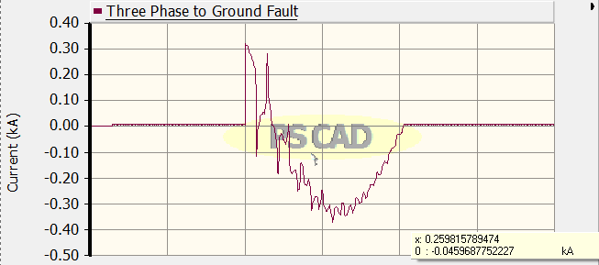

The maximum value is about 0.4540 kA, but calculated value from step C (1), the magnitude is 1.4669 kA, which is larger than the value we obtain from PSCAD.

2) Single-phase-to-ground 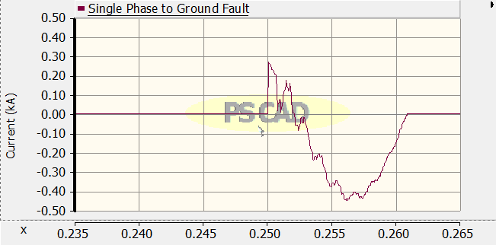

The maximum value is about 0.5163 kA, but calculated value from step C (2), the magnitude is 1.1183 kA, which is larger than the value we obtain from PSCAD.

3) Two phase

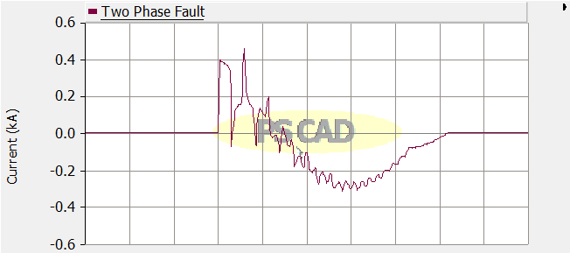

The maximum value is about 0.5132 kA, but calculated value from step C (3), the magnitude is 1.2704 kA, which is larger than the value we obtain from PSCAD.

1. Two phase to ground

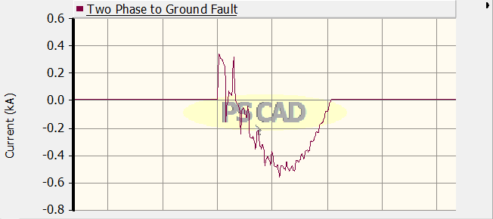

The maximum value is about 0.5180 kA, but calculated value step C (4), the magnitude is 1.4088 kA, which is larger than the value we obtain from PSCAD.

The reason for the difference is:

1. The value we read from the figure may be incorrect
2. The time break logic will trip for some time, this can cause the error
3. Timed fault logic has applied certain time